Journeying Through The Lectionary And The Liturgical Year

Presented by:
Felix Just, SJ, Ph.D.

Saturday, Oct. 23, 2010

9:00 a.m. – 4:00 p.m.
What is the Lectionary for Mass? How was it developed? How were its contents selected and arranged? What is its relationship to the Bible? How can it be used not only during Mass, but also in other spiritual and pastoral ways? This workshop will deepen your understanding and appreciation for the Roman Catholic Lectionary and increase your ability to use it well throughout the liturgical year.

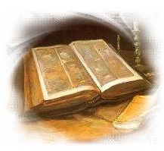

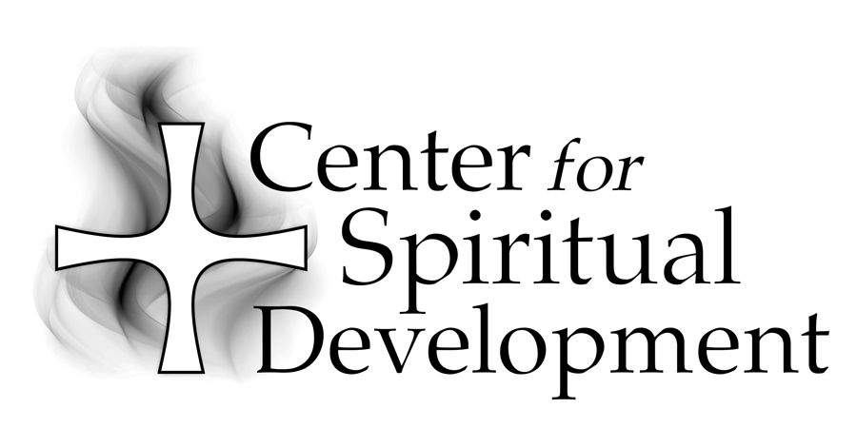
Location:St. Joseph Center Library Conference Room
480 South Batavia Street
Orange, CA 92868

St. Joseph Center is located next to the 22 freeway at the corner of La Veta and Batavia in the City of Orange. Directions are provided with registration.

Fee: $30 (bring a brown bag lunch)

To Register:
Please call (714) 744-3175, x4409 or e-mail
gscharff@csjorange.org.

Sponsored by:

A Ministry of the Sisters of St. Joseph of Orange
434 South Batavia Street
Orange, CA 92868-3907

Phone:(714) 744-3175
Fax:(714) 744-3176
E-mail:csdinfo@csjorange.org
Web:www.thecsd.com

Felix Just, SJ, Ph.D., a member of the California Province of the Society of Jesus (the Jesuits), is the Director of Biblical Education at the Loyola Institute for Spirituality in Orange, CA, Academic Coordinator of lay and deacon formation programs in the Diocese of Las Vegas, and a gifted and much sought after retreat presenter. Felix, who has a Ph.D. in New Testament Studies from Yale, has taught at numerous Jesuit universities.

