ENCOUNTERING JESUS DURING LENT:
Holy Scripture for a Holy Season

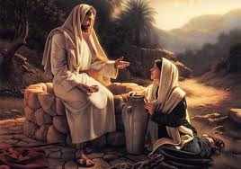
Presented by:
Felix Just, SJ, Ph.D.

Saturday, Mar. 5, 2011

9:00 a.m. – 4:00 p.m.
To help us “encounter” Jesus more closely, we will look in depth at the scriptures used on Sundays of Lent in 2011 (Year “A” of the Lectionary for Mass), especially the stories from John’s Gospel in which Jesus encounters the Samaritan Woman, a Man Born Blind, and the Sisters of Lazarus. This one-day workshop will include a combination of lecture discussion, prayer, and time for reflection. Please remember to bring your Bible.

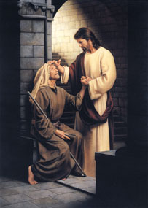

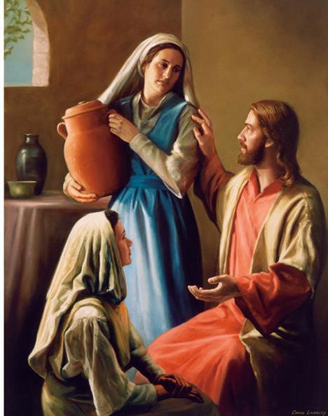

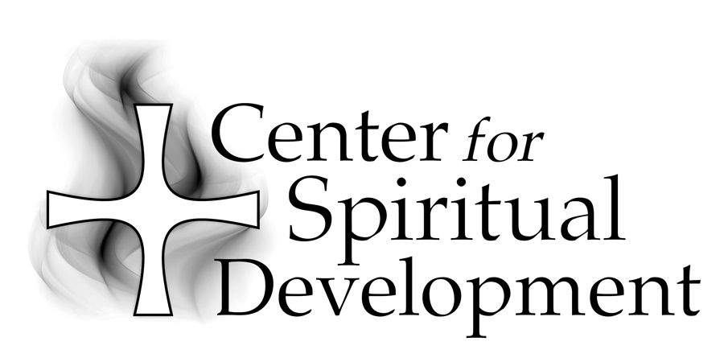
Location :St. Joseph Center
Library Conference Room
480 South Batavia Street Orange, CA 92868

St. Joseph Center is located next to the 22 freeway at the corner of La Veta and Batavia in the City of Orange. Directions are provided with registration.

Fee: $30 (bring a brown bag lunch)

To Register:
Please call (714) 744-3175, x4409 or e-mail
gscharff@csjorange.org.

Sponsored by:

A Ministry of the Sisters of St. Joseph of Orange
434 South Batavia Street
Orange, CA 92868-3907

Phone:(714) 744-3175
Fax:(714) 744-3176
E-mail:csdinfo@csjorange.org
Web:www.thecsd.com

Felix Just, SJ, Ph.D., a member of the California Province of the Society of Jesus (the Jesuits), is the Director of Biblical Education at the Loyola Institute for Spirituality in Orange, CA, Academic Coordinator of lay and deacon formation programs in the Diocese of Las Vegas, and a gifted and much sought after retreat presenter. Felix, who has a Ph.D. in New Testament Studies from Yale, has taught at numerous Jesuit universities.

