“WHAT’S NEW ABOUT THE NEW ROMAN MISSAL?”

Presented by:
Felix Just, SJ, Ph.D.

Saturday, Oct. 29, 2011

9:00 a.m. – 12:30 p.m.
On the First Sunday of Advent, the Church celebrates the launch of the new English translation of the Roman Missal. This workshop will explore the changes in the Mass, the history and development of the Roman Missal, and the impact of the contemporary English-speaking world on this new translation. In preparation, please look at the website of the United States Conference of Catholic Bishops, (http://www.usccb.org/romanmissal/), and bring along your “Missal” or “Missalette.”

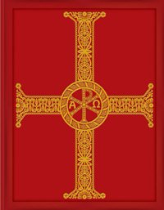

Felix Just, S .J ., Ph .D ., a member of the California Province of the Society of Jesus (the Jesuits), is the Director of Biblical Education at the Loyola Institute for Spirituality in Orange, CA, and a core instructor in the Catholic Bible Institutes and the lay ministry and deacon formation programs of several dioceses. Having earned his Ph.D. in New Testament Studies from Yale, he has taught at several Jesuit universities, and is a dynamic speaker and gifted retreat presenter.
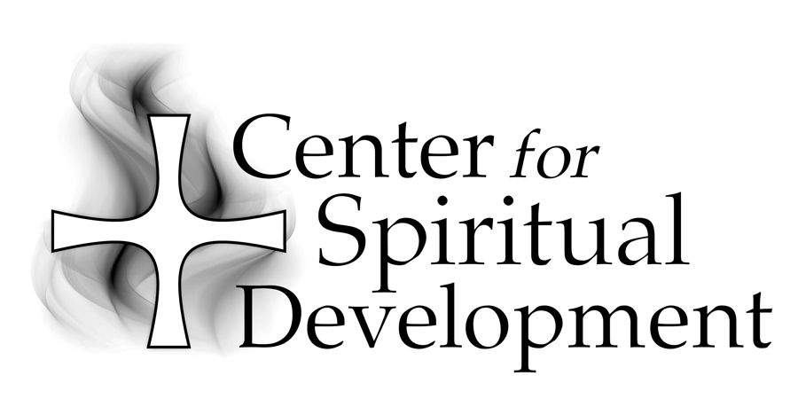
Location:St. Joseph Center
Library Conference Room
480 South Batavia Street
Orange, CA 92868

St. Joseph Center is located next to the 22 freeway at the corner of La Veta and Batavia in the City of Orange. Directions are provided with registration.

Fee:$25

To Register:
Please call (714) 744-3175, x4409 or e-mail
gscharff@csjorange.org.

Sponsored by:

A Ministry of the Sisters of St. Joseph of Orange
434 South Batavia Street
Orange, CA 92868-3907

Phone:(714) 744-3175
Fax:(714) 744-3176
E-mail:csdinfo@csjorange.org
Web:www.thecsd.com

